Superintendent Parent Forum
Event Plan

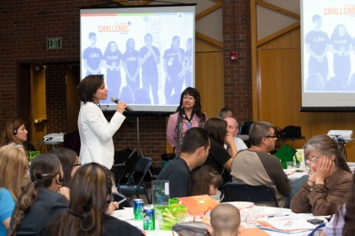
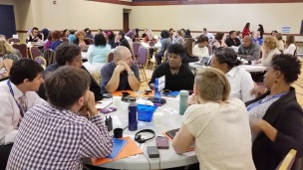

TIME DURATION: 8-6 weeks

Phase 1 – CONTENT CREATION – WEEK 8 & 6 (before the Forum)
- Creation of Agenda (public or general agenda – see doc attached)
- Creation of Staff Agenda which include minutes (see doc attached)
- Schedule meeting with content experts to develop agenda – as needed
- Developing material to be presented during event

  - WEEK 4 & 3
- If you are going to have table activities, create a table facilitator guide (see doc attached)
- Creation of blank Sign-in sheets (see doc attached)
- Determine the number of volunteers needed and tasks to be assigned (see doc attached)
- Request volunteers via email, phone, etc. (See doc attached)

Phase 2 – MESSAGE AND REGISTRATION – WEEK 4 & 3
- Creation of Flyer (see doc attached)
- Translation of Flyer
- Gather list of parents
- Gather list of schools’ authorities
- Gather list of schools’ contacts – people who will help you to promote the event
- Gather list of community partners
- Gather list of local broadcasting media
- Gather list of schools and online community calendars
- Gather list of volunteers whom will assist you in promoting the forum (create a page specifying roles and responsibilities – see doc attach)
- Create a google form to register attendees – the link to this form should be included in the District Website, email invitations, and text messages for parents to register (follow this link to see our registration form: http://goo.gl/forms/LtIIfxnkBq

Phase 3 – COMMUNICATIONS (District Level) – Week 4, 3 & 2 before the Forum
Highly advisable – Get a letter from Superintendent asking principals to support the Forum by disseminating information regarding the event at their respective schools
- Include Flyer in District Website – Announce the event
- Post event on District Social Media Outlets – Facebook, Twitter, etc.
- Post event in schools Newsletters and/or school websites/social media
- Send emails to participants/parents
- Send flyer to parents via regular mail
- Send emails to schools’ authorities and contacts to promote the event
- Ask school’s contact to post event flyer on the school’s bulletin boards and social media outlets
- Use the District Robo-call system to announce the event
- Use the text messaging system to promote the event
- Add event on schools’ calendars
- Add event on online community calendars
- Make personal phone calls to parents to invite them to attend

(External Communications)
- Send flyer to community organizations who can help you disseminate information regarding the event
- Ask community partners to promote the event using their social media outlets
- Contact council members by phone to ask for their collaboration in promoting the event via their social media outlets or newsletters – Send information to those who accepted
- Send information about the event as press releases or public service announcements to local media: newspapers, radios, TV stations.

Phase 4 – LOGISTICS – Week 2 & 1 before the Forum
- Order Supplies: paper, pencils, any material that may be used at the forum
- Order the audio visual system: projectors, screens, microphone, etc.
- Make copies of the material – have it in different languages
- Order food based on potential number of attendees
- Order interpretation services as needed
- Arrange babysitting for parents with children
- Book location – number of tables, chairs, table cloths, etc.
- Decoration: banners, pictures, flowers, ornaments, etc.
- Decide lay out of the event – select registration area, and other areas as needed
- Send email to volunteers specifying roles and responsibilities

Phase 5 – AT THE FORUM
- Registration area – have the blank sign-in sheets ready for people who did not RSVP. In addition, have a printout list with the RSVP attendees obtained from the google form or any other source you’ve used.
- registration form for childcare – parent need to sign when leaving their children
- Have list of volunteers with roles and responsibilities

Phase 6 – AFTER THE FORUM
- Compile list of attendees
- Call for the debrief meeting to discuss what can be improved for next time.
- Prepare budget and analyze costs
Then, start all over again…

